Memo

Date: December 2000
To: John Sherriff, Richard Lewis, Simon Hastings, Fernley Dyson, Mike Jordan, David Port, Micheal Brown, Ted Murphy, Sally Beck, Chris Abel

From: Mike Wellings/James New
Re: UK Power – November 2000 Curve Validation and Profit and Loss Report
The purpose of this memorandum is to summarise our review of the UK Power Curves used as at the 30th November 2000 and analyse the reported profits of the book.

A- Executive Summary
Having reviewed and validated the 30th November 2000 UK Power Curves and considered the appropriateness of any significant changes in inputs and assumptions, we conclude the curves are fairly constructed with an objective methodology, using the latest data, where available, and are consistent with relevant market information. The profit for the month of November was £19.5m (October £4.4m profit) and the total net assets were £308.6m (October £289.1m).

Of the profit of £19.5m the main drivers were:
- £6.6m profit for intramonth on falling prices
- £6.6m profit due to forward curve and origination earnings
- £7.8m profit on Energy Trends
- £1.5m loss on Inter connector Availability
Delta (Fwd) | Delta (I month) | Gamma | Vega | Theta | Rho
13,655,608 | 6,626,569 | (5,643) | (103) | 8,910 | 0
Origination | Cross terms | Rebooking | PPI inflation | Prudency | Brokerage
1,886,218 | (283,999) | (179,835) | 223,983 | - | (930,759)
Further details can be found in the profit and loss commentary under section C.
The number of November trades at 1,235 (October 787 trades) was again the highest volume for the fourth month in succession. This continues to confirm the growth of liquidity in the prompt period months ahead of the implementation of NETA.
The most actively traded was for the prompt months - 66% of trades were completed up to December 2000. Winter 2000 reduced significantly as a traded period to 2% of trades done from 14% for September. The increase in promt trading and reduction post March 2001 is largely due to market concern over post NETA trading and the terms of the new Grid Trade Master Agreements and PPP replacement pricing. Some longer term trades were still completed – 4 trades were entered into for Summer 2004 with Dynergy UK Limited, view is that these counterparties were entering into these to validate curve positions.

The trades in the period are summarised below:
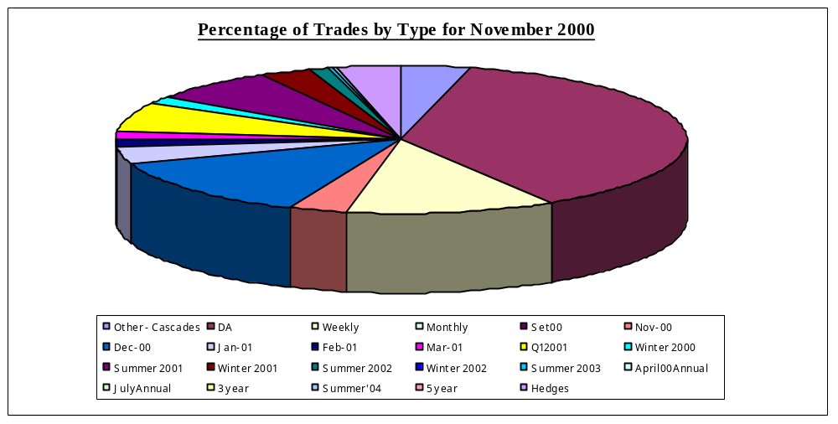

No trades were completed with the UKPX in the review period. The cash held on exchange was £246,733 an increase of £8,929 from October 2000.

During November 329 trades were completed on Enron Online (EOL) (164 during October) – 29% of total deals (October 23%). Entergy were still the counter party most frequently traded with 98 trades in the period (56 trades in October).
The value of the trades for EOL at 30th November was £(37.5)m, (October £(41.8)m) - during November Enron has taken a short position of approximately 0.6TWh on line. (October short position of 1.6 TWh)
The EOL portfolio split for the month are summarised below:
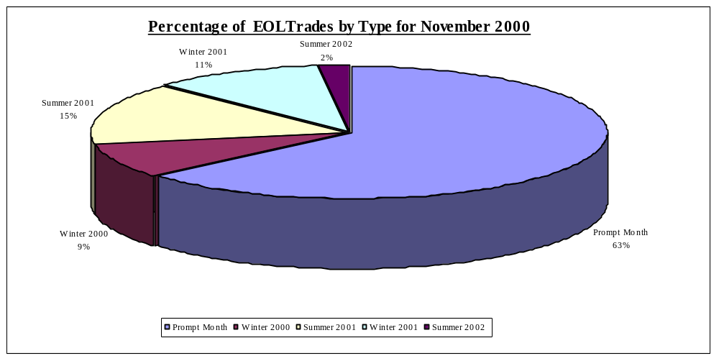

NETA – During the month Participation Integration Testing (PIT’s) were commenced, with a deadline for completion of 22nd December. Uncertainty still reigns over the exact nature of forward contracts in the post NETA world, as the proposed Grid Trade Master forward Contract price will be closer to a NBP contract in the UK gas market. The conversion of current PPP contracts to GTMA prices is causing concern as the pricing of transmission and balancing would expose parties to regulatory risk. One solution being discussed is treating these costs as a pass through similar to VAT. This uncertainty has severely hampered trading in recent weeks.

B - Curve Validation

1. Methodology
The curves have been reviewed using the following criteria, and have been split in the same way as in the UK Power Market Forward Curves Document (September 2000).
Broker Quote Variance Front End
- Historical Trades / Press reports Middle
- Curve Construction Back End

2. Review – Power Delta

The changes in the curve for the month is reflected below:
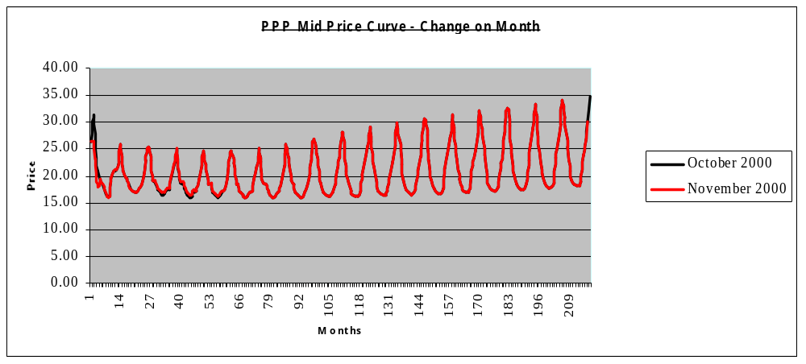

2.1 Broker Quotes Front End (January 2001 – October 2003)

Broker prices that were available for different load shapes and time periods were compared with the curve as at 30th November 2000.The total implied overstatement of profits was estimated to be £137k (October £85k understated) which was considered immaterial.
The market curve for Winter 2000 and Summer 2001 are 2p below the broker quotes, giving an estimated understatement of £33k and overstatement of £31k respectively. Winter 2002 was 7p above the broker quotes, giving an over statement of £88k. Other variances, totalling £51k overstated was immaterial.
This method of validation is only relevant for the period for which quotes were available. Therefore, this method only verifies the curve for the first 18 months.
The analysis of the broker quotes for the front end of the curve over the quarter has shown that the traders curves have been consistent. The large movements in the market have been evidenced via the broker quotes, and matched daily to the Enron curves.

2.2 Historical Trades Middle ( 2003 – 2010)
During the period the middle curve was reviewed out to 2010, in view of out turn prices for the liquid part of the curve. Four trades were completed in the period with Dynery UK Limited and Innogy plc. The low origination on these trades indicated that the curve was correctly marked.

2.3 Curve Construction Back End (2010-2025)
The back end of the curve did not move during November.
Over the long term the curve is partitioned by considering the long-term cost of producing electricity. Using the Gas Forward curve and the latest economics for a 1200MW plant and using Enron’s forecast market heat rate curve it is possible to create a forward cost of power from the latest CCGT i.e. the most efficient plant available.

In recent periods there has been a large increase in the price of gas with the implied increase per Mwh in the cost of gas for the period 2010 to 2025 to 275 pence.
The Government imposed ‘Moratorium’ on building new gas fired power stations was removed in the period, this coupled with the implementation of NETA will have a bearish effect on prices so that the expected site and site permit costs will fall considerably. This assumption is supported by the current Kent Power project. The implied decrease per Mwh in the cost of gas for the period 2010 to 2025 was in excess of 275 pence.
Full details and support are documented in the Power Market Forward Curves Document (September 2000) and this should be read in conjunction with this memo.

3 Review – Other Risk Variables
Interest rate risk is not reviewed as all P&L derived from this is passed to the Interest rate book. The UK Power book has in this quarter accrued interest from the NP Accrual Book. This interest is then swapped to the Interest Rate Desk to offset against the negative theta cash flows on the out of the money PPA contract.
The present value of options and swaptions was £(13.9)m (September £(16.0)m) with maturities going out to October 2005 (August October 2005)
There are no market quotes for implied volatilities. Trades are compared to volatilities implied from option trades completed or reported in the month to ensure consistency. Volatility ladders were calculated to quantify the sensitivity of the portfolio to volatility moves. Enron is net long volatility – . For a base load volatility move of +/- 1% the implied P&L would be a profit of £95k / loss of £101k respectively (October profit of £74k / loss of £80k) For a move of +/- 5% the implied P&L would be a profit of £414k/loss of £484k respectively. In relation to the size of the book the vega sensitivity is not considered material.
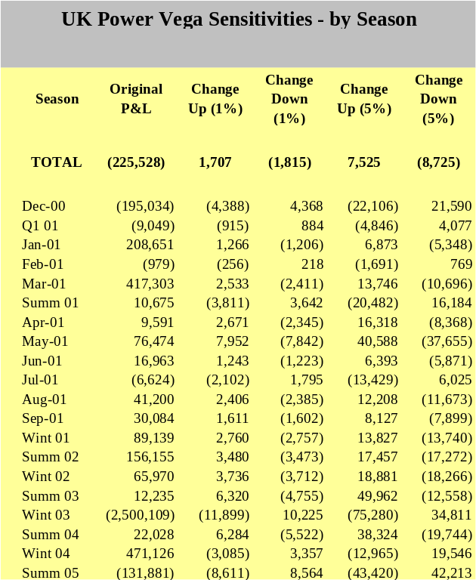
Average results by season are reflected below:
There were 27 swaptions / options traded this month by Enron (October 6) – In November 12 weekly options were traded for the first time.
The volatility on these trades was on average 32% (September 19%) – These options were for April – September 2001.

C – P&L Commentary

1. Profit and Loss changes

The P&L for November was a profit of £21,000,949 - Income drivers are summarised below
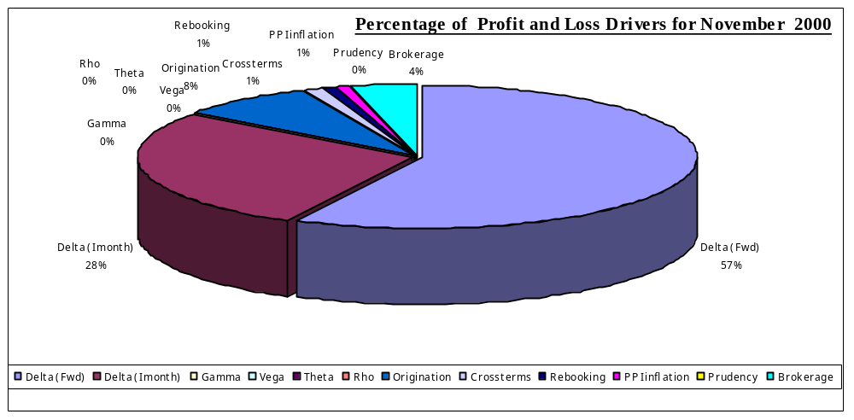

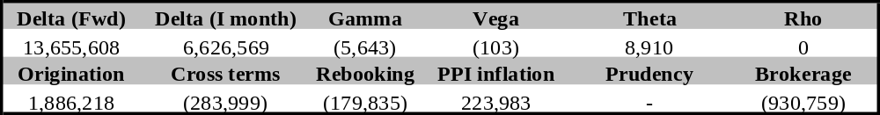
The main changes for the month were:
- Intra Month Profits of £6.6M on a short position, this is largely due to reduced out turn prices for November due to plant returning on line and low seasonal temperatures. The boyant December prompt month also liquidated in the period. Significant price falls were made in the month, as December moved to realign itself against the November out turn prices. This trend is continued into the December period. With the low outturn for November the whole of the prompt looks well overvalued – as the back end of December is all holidays prices should be lower for the month than they were for November.
- Energy Trends Profits of £7.8M due to a revision of the assumptions concerning Climate Change Levy (“CCL”). This is due to the current DTI proposal to publish two tables, one including CCL and one excluding. Management view is that for the contracts that Enron has with Energy Trends indexation (J Block and National Power PPA), these should be indexed to the table that excludes CCL as this is an exact continuation of the existing published table.
- Delta profits of £6.6M on an overall short position, the majority of these earnings have been generated in Winter 2001, this is a direct knock on as a result of the low out turn prices being experienced for Winter 2000. This is detailed below:
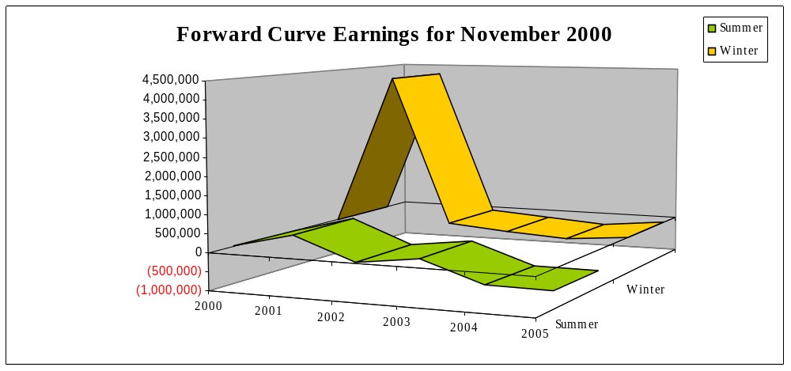

.

Realised Profit
The realised profit for November was £10.6m (October 12.3m profit).
- PPP £10.8m profit (October £12.7m loss)
- SMP £0m gain (October £0m gain)
- LOLP £0.2 loss (October £0.4m gain)

The total realised loss for the eleven months to November was £0.9m

3. Prudency
All volumetric and general prudency reserves were released in Q3 2000. As a direct result of the increase in liquidity in the UK Power markets over the first three quarters of the year Enron Europe management believe non-transaction specific provisions are no longer required to cover liquidations costs of trading positions.

Management believes that no transaction provisions for specific identified risks within deals should be provided for in November 2000.

4. Monthly Curve & Volumeric Movement

- Baseload prices for January 2001 moved down by £4.96/MWh on average
- The balance of Winter 2000 moved down by £2.00/MWh on average – peaks fell by £1.87 off peaks by £2.07
- Summers for 2001 – 2006 rose marginally on average by £0.18Wh
- Winters for 2001 – 2006 also rose marginally by £0.10/Wh
- The back end shifts from 2007 was unchanged.

The 3 year October baseload price has increased from £18.22/MWh at the end of October to £19.67/MWh at the end of November. The 5 year November base load price has risen from £18.32/MWh to £19.42/MWh. The 10 year November base load price has also risen from £18.32/MWh at the end of October to £19.29/MWh .
The most actively traded periods were: Winter 2000 (Short 1,472,609 MWhrs) Summer 2001 (Short 724,671 MWhrs ) Winter 2001 (Long 530,157 MWhrs) The additional length taken in 2001 reflected the need to reduce our post NETA short position. This movement in position for November is reflected below:

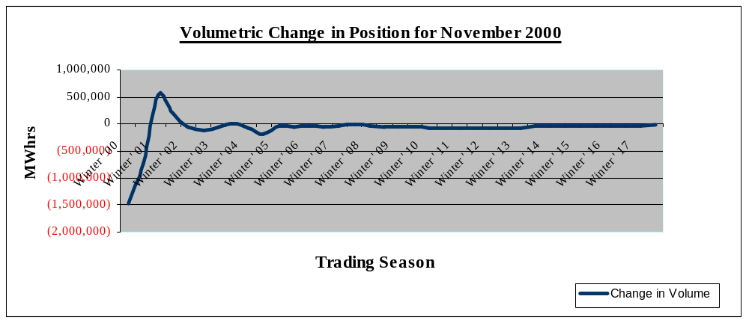

The total position is reflected below:

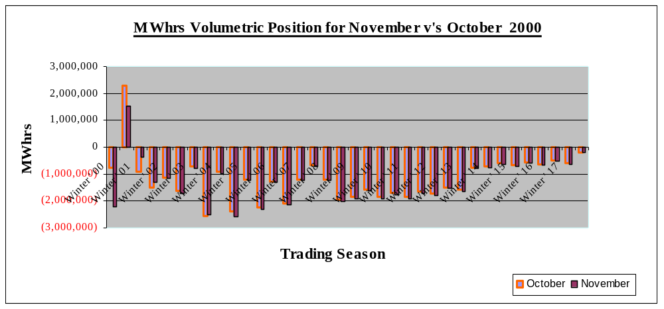

5. Energy Trends Electricity

The current MTM of the Energy Trends position as at 30th November was £3,040,433 - October £(1,098,377)
The profit in the period was due to the reversal of the Climate Change Levy, which was originally factored into the full loaded Energy Trends price.

6. Value at Risk
The 1day value at risk at 30th November was £10,397,106 using a 5% 1tail confidence interval (October £10,010,752). No violations occurred in the review period.

Appendix 1.

Broker Quotes Comparison

Appendix 2.

Curve shift impact and curve movement for PPP

Appendix 3.

Curve shift impact and curve movement for LOLP

Appendix 4.

Curve shift impact and curve movement for SMP

Appendix 5.

Delta Volumes

Appendix 6.

P&L analysis split.

Appendix 7.

Peak / Off Peak / Baseload monthly curve shift and P&L analysis.

Appendix 8.

Graph to show amounts Settled per month and the book Profit for the month.

